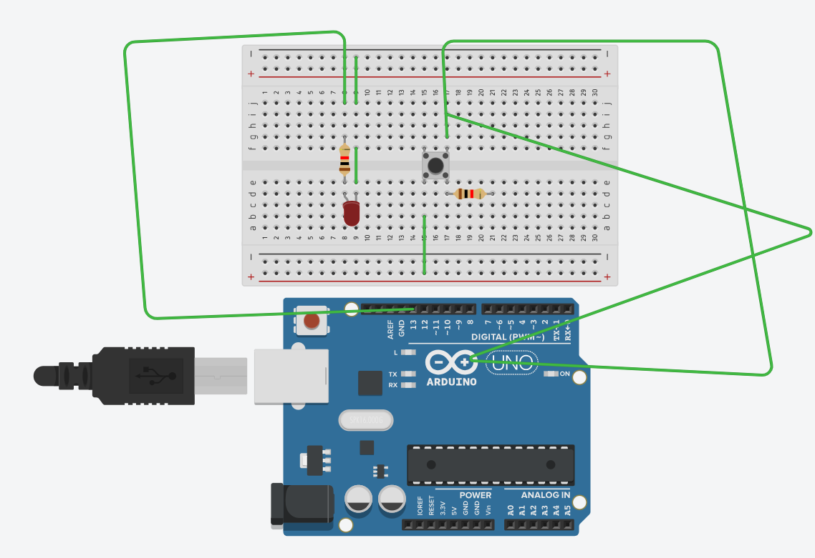

int led = 13;
int pushButton = 2;
void setup() {
Serial.begin(9600);
pinMode(pushButton, INPUT);
pinMode(led, OUTPUT);
}
void loop()
{
int buttonState = digitalRead(pushButton);
Serial.println(buttonState);
if (buttonState == 1 {
digitalWrite(led, HIGH);
}
else
{ digitalWrite(led, LOW);
}
delay(1);
}

